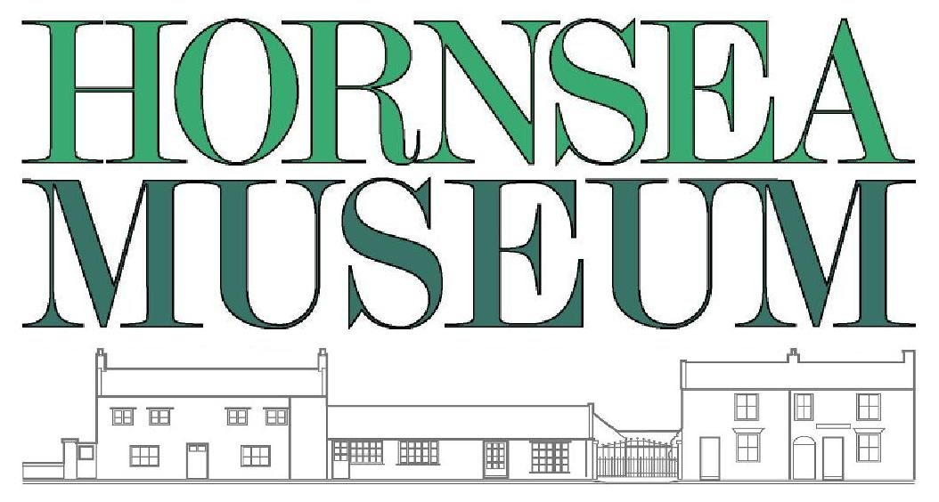
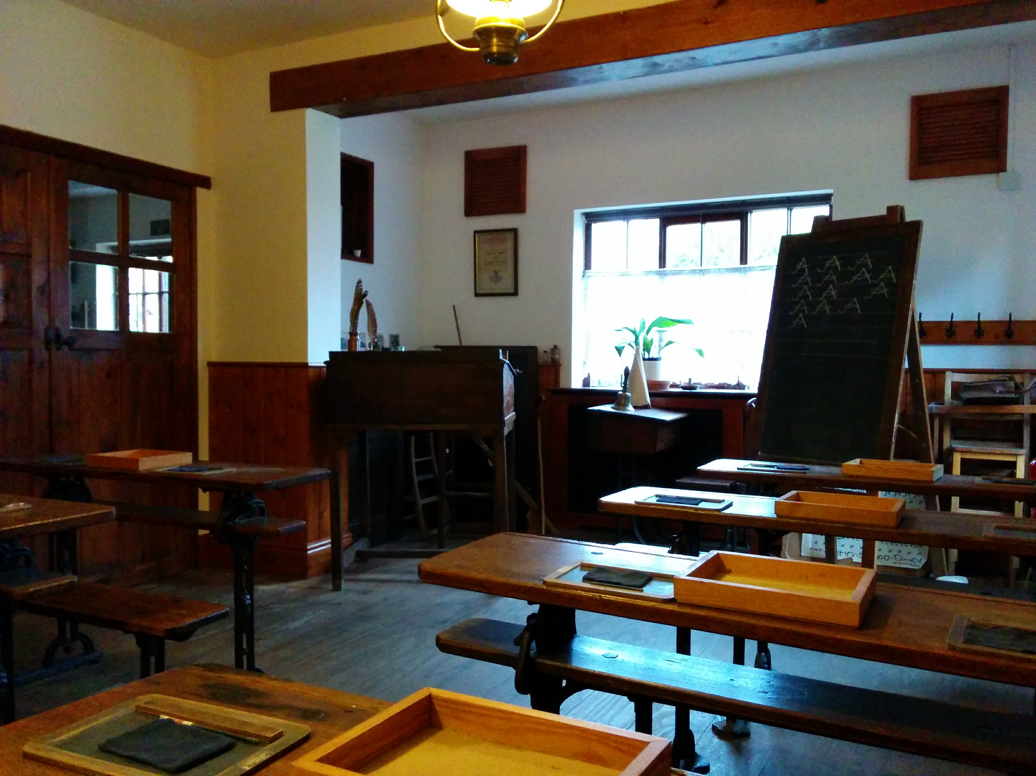
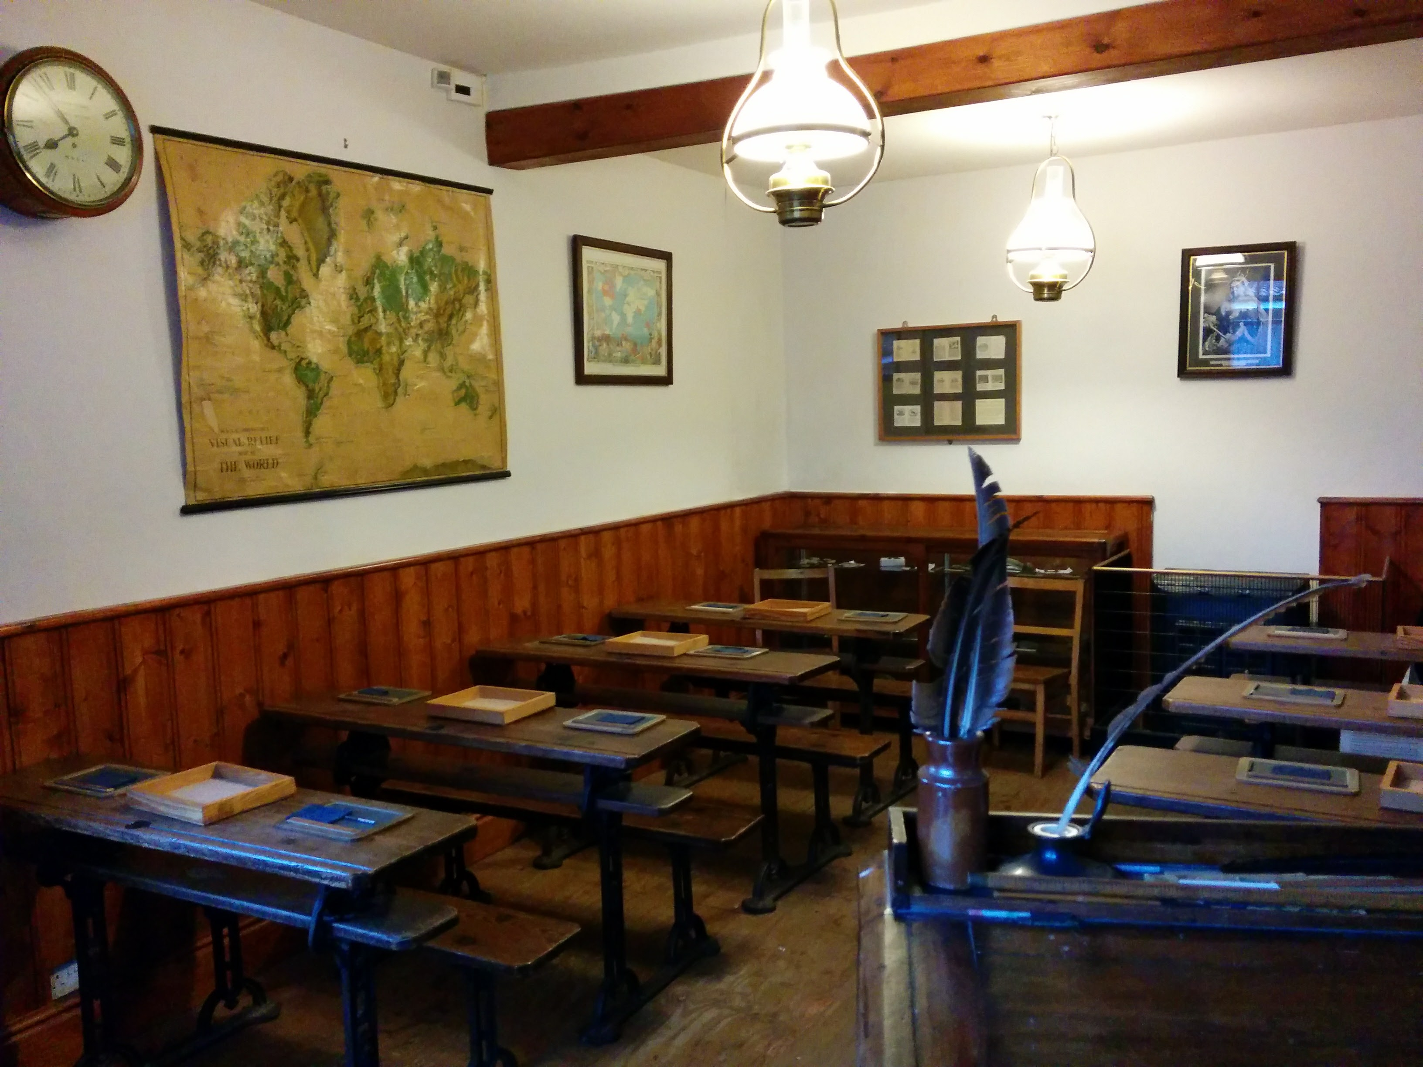
A typical Key Stage 1 or 2 School Visit to Hornsea Museum

What to expect

School bookings can be made throughout the year.
Please note that due to the age of the buildings, the museum can be cold, so please advise parents to dress their children in warm clothes.
If you are not coming for a full day, we would suggest you allow a minimum of two hours for the Victorian workshop.

School visits usually start at 10am but we can be flexible.

The museum can accommodate approximately 30 children.
If you have more than one class, we can spread this over the morning and afternoon.

On arrival you will be directed to the education room. There is plenty of space to hang coats, bags, and packed lunches.
If the children are not already dressed up, we provide Victorian clothing for them to wear.
There will be a brief introduction about the museum, and we will explain what they are going to be doing.
The children will be divided into three equal groups. (It makes it a little easier if you have arranged your three groups before the visit.)
Each group will start in a different area of the museum.

The School Room
The children will experience a Victorian style lesson given by Miss/Mr Grimm, the class teacher. We always ensure the children know we are in character so as not to worry very young class members.
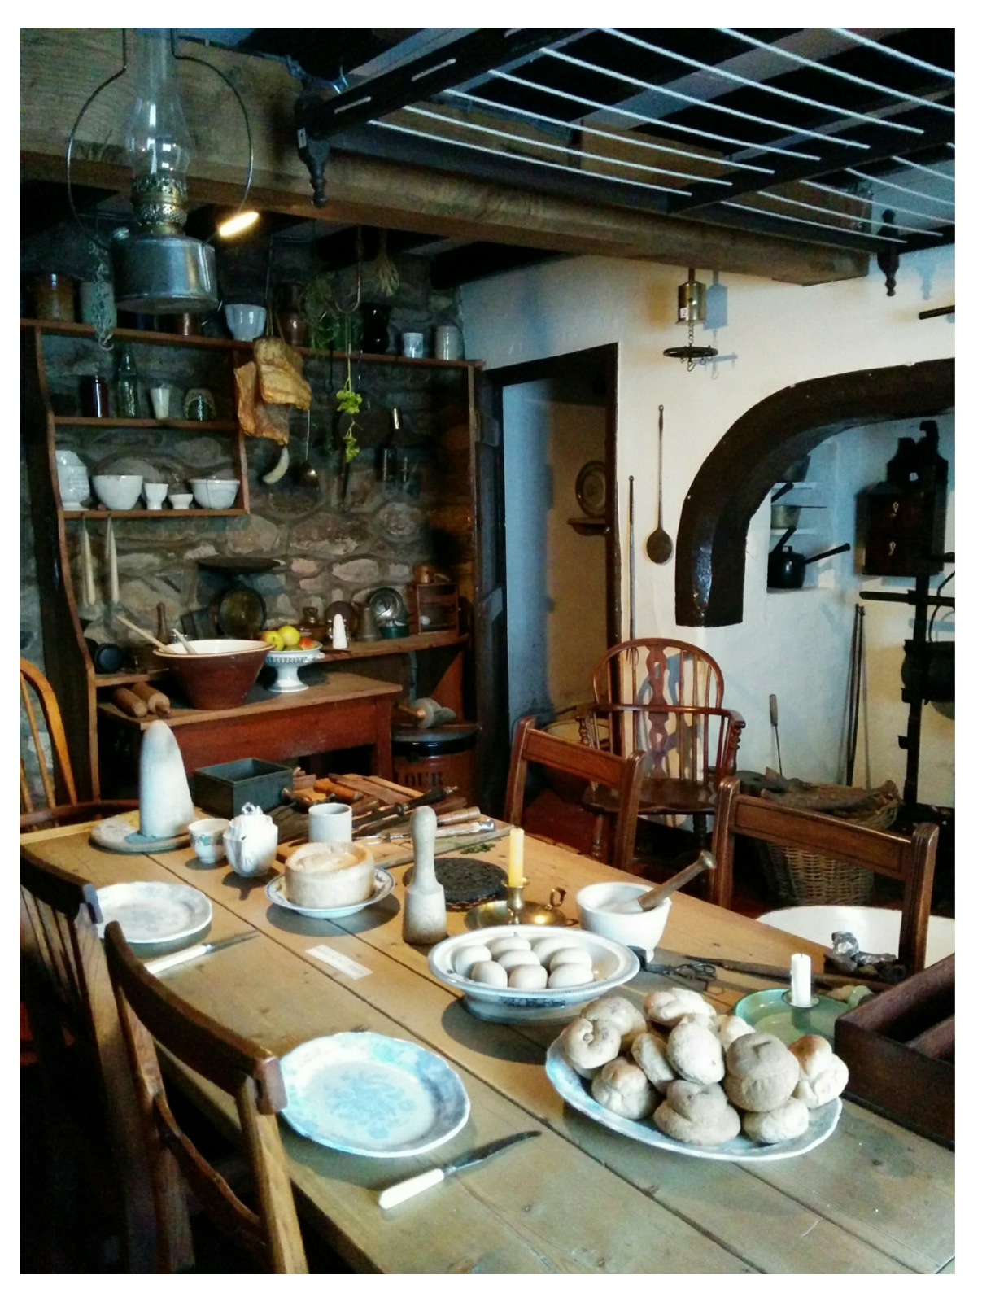
The Farmhouse Kitchen
This is where the children can talk to Mrs Burn as she carries out some everyday tasks in her kitchen. They will see how home life as a Victorian is so very different from today.

Farmhouse Mini-Tour
This is an alternative, depending on the availability of volunteers, and may be more suitable for children at KS1. The time in the kitchen is reduced, and is followed by visits to the . Victorian Parlour, Bedroom, and Childhood Room (toys).

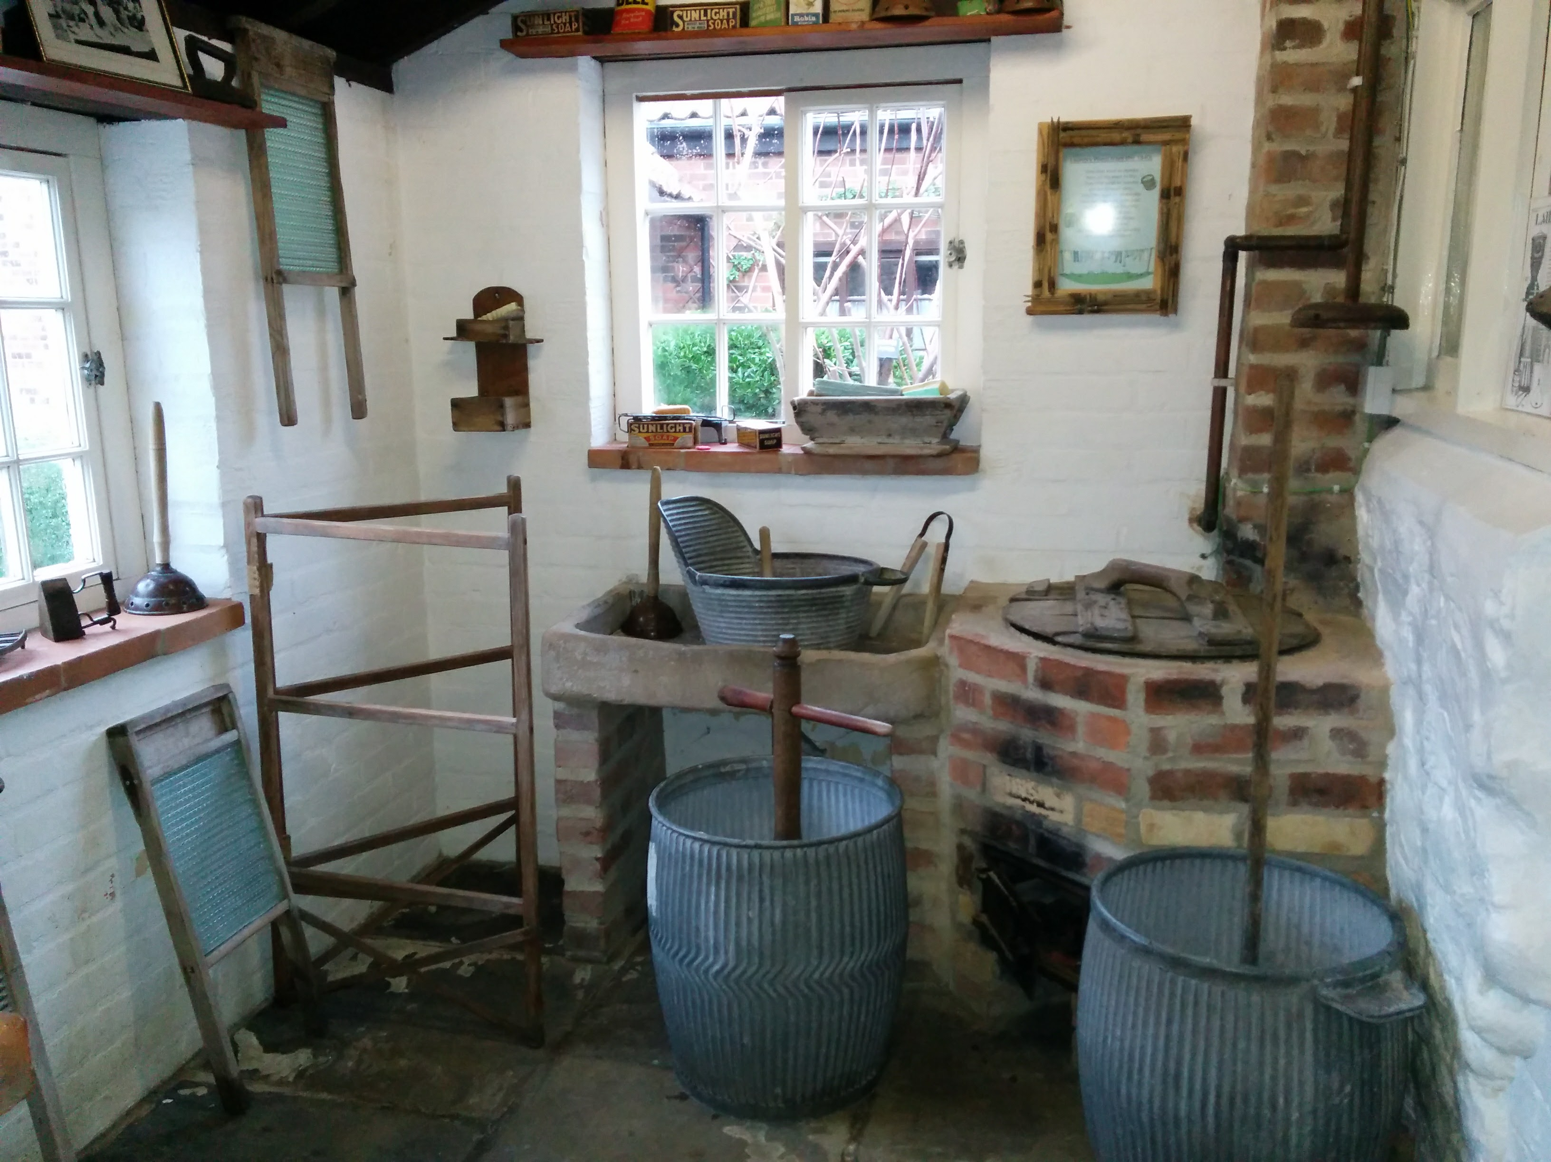
The Wash House
Time to mess with water!
The children will learn about wash day in Victorian times and how much hard work it was.
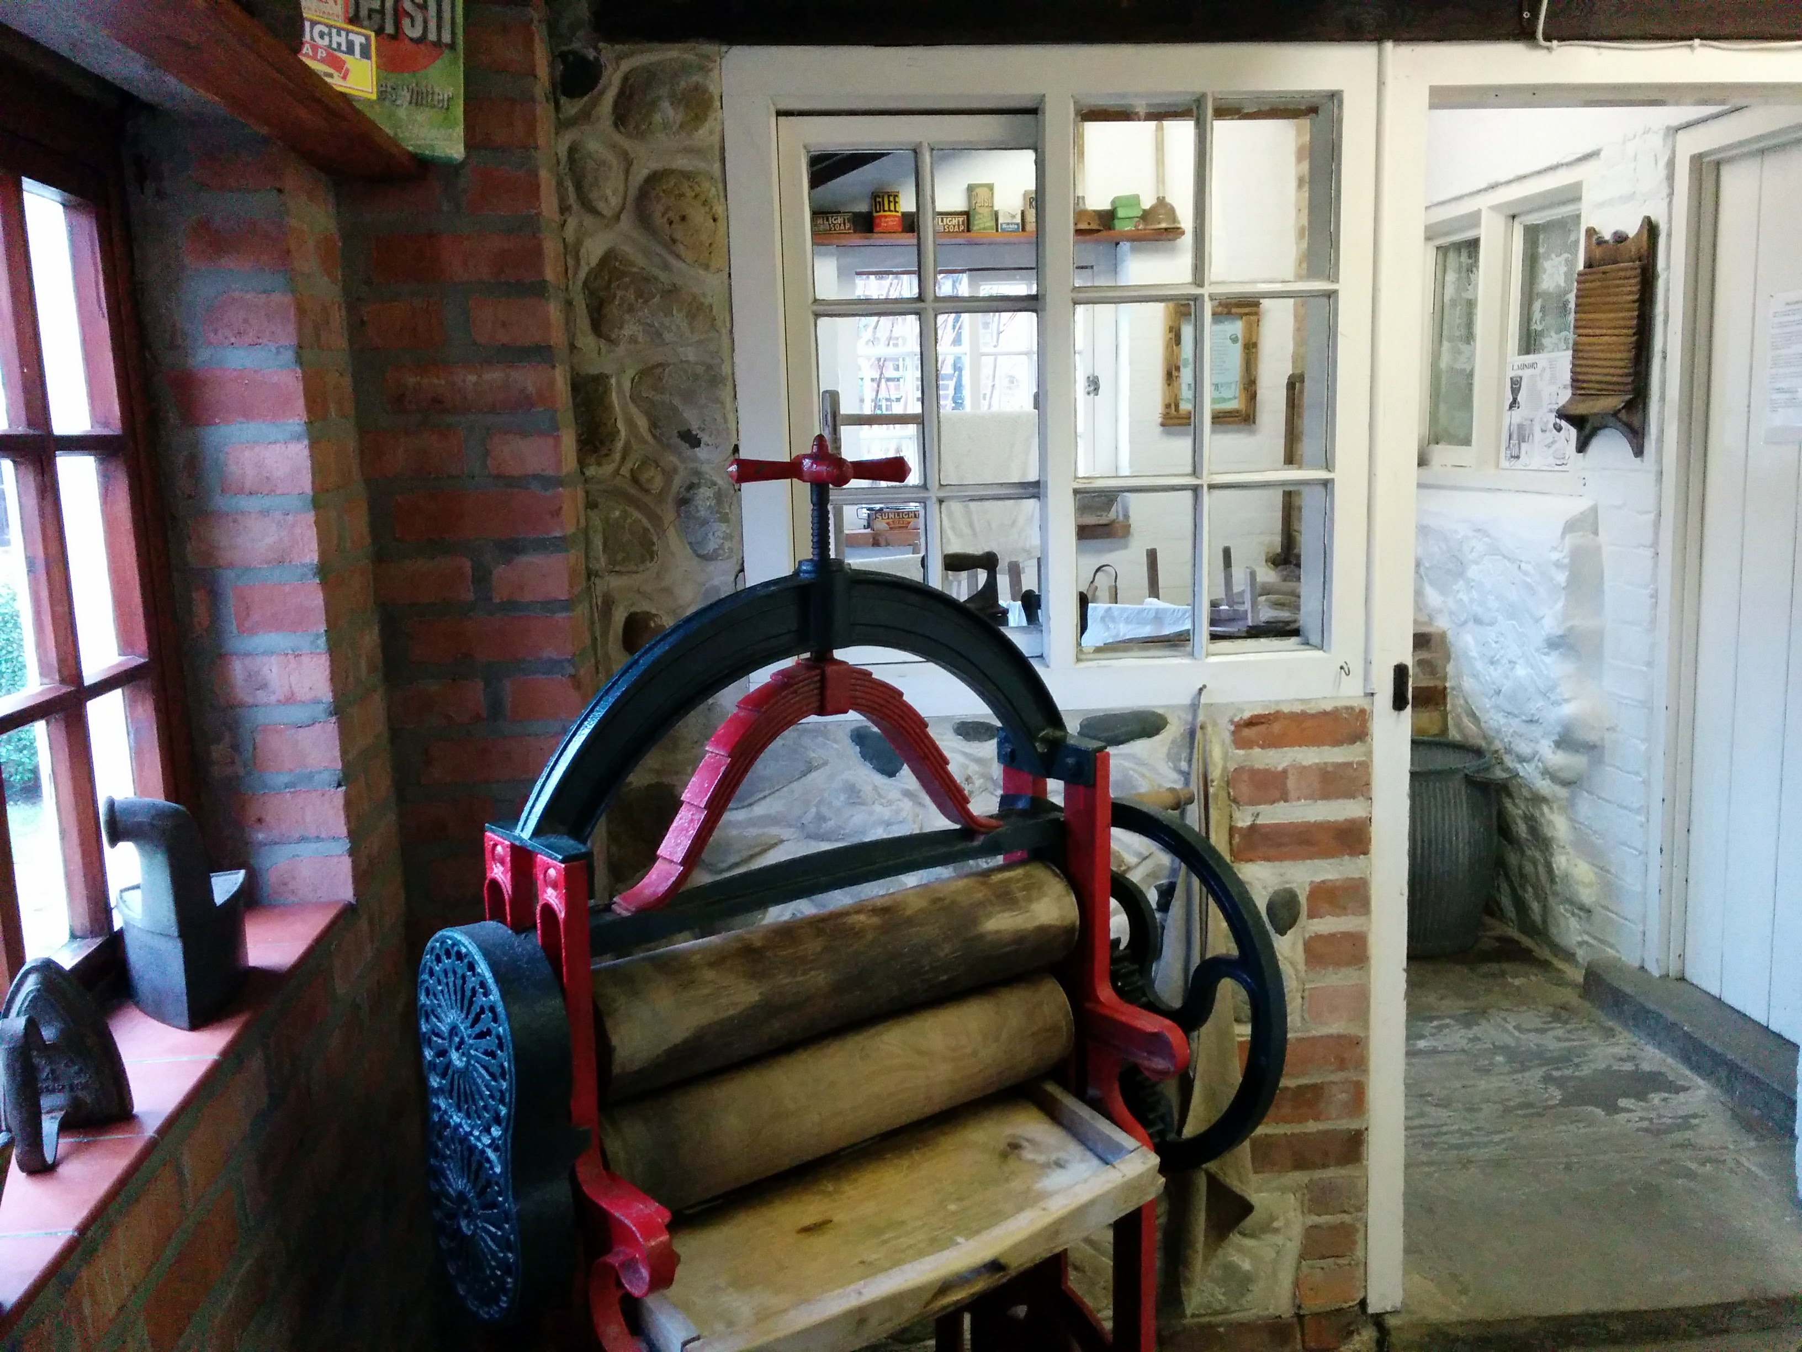
They will each get chance to use the dolly in the dolly tubs, scrub with the wash boards and wring the wet clothes with the mangle. If time, they will have a turn with the carpet beater and hang out their clean washing.

Each activity lasts about 25 minutes after which a school bell will ring, and the children move round. This usually takes us until lunch time.

In inclement weather the education room is available for the children to eat their packed lunch and we also have a lovely garden with picnic benches. Please take all your rubbish home with you.

If you are staying with us for the full day, there is still plenty of the museum left to see including a new railway building and a childhood room.
You may also like to organise a task for the children to complete in the afternoon such as a visit to the seafront.

We have a gift shop at the museum and, as a charity, we really would appreciate it if the children brought along some pocket money for a souvenir.
We suggest between £2 and £5.
We advise that the children come to the shop in their set groups.

If you have not been to the museum before, we suggest you come for a free pre-visit.
Please arrange this in advance so a member of the education team can meet with you.

Payment
On the day of your visit you will be invoiced (paper copy and via email).
We don't advise pre-payment as numbers can often change due to illness.
Please make cheques payable to ‘Hornsea Museum’.
Alternatively, you can arrange a BACS payment.

